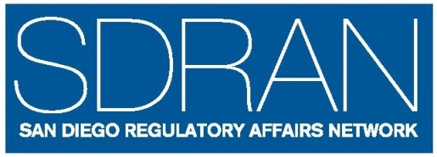 | SDRAN Mentoring Program  2021 PROGRAM ANNOUNCEMENT
SDRAN Mentoring Program is Accepting Applications for 2021

SDRAN will be accepting applications for the Mentoring Program starting March 09, 2021 to help promote the career growth and development of SDRAN Members and to strengthen the regulatory affairs profession. Applications will accepted until March 17, 2021 for the Mentoring Session to begin in April 2021.
A Mentoring Program is a process for professional and personal development in which an individual (the mentee) strives to achieve a development goal(s) under the guidance of a more experienced colleague (the mentor). Mentoring is not intended to help mentees find new jobs but can be helpful if they want to change careers or advance in their current career path. For mentors, helping others can be a fulfilling and satisfying experience.
The goals for the SDRAN program are
- to enable members to enhance their knowledge/experience in their current job function, or
- to advance in their current career path, or
- to provide members with guidance to pursue a different or new career path within the general areas of:
  - Regulatory
  - Clinical
  - Quality Assurance or Quality Control
The minimum qualifications to participate are:
- You are a current SDRAN member
- You either live or work in San Diego or Orange County
- You commit to 6 months to interact with your mentor/mentee, 2-4 hours per month; mentees are expected to spend additional time (2-4 hours per month) preparing for meetings
- You complete the SDRAN Mentee or Mentor Application Form. Please see the Application Form for additional qualifications and requirements.
- Mentees are required to attend the Mentoring Program Session scheduled for March 09, 2021 and to meet minimum education requirements (see application form).

For more program information and an application, go to
http://www.sdran.org and click the “Mentoring” button

